|  |  |
| --- | --- |
| Open up the My Teaching Strategies Teacher App and log in. |  |
| Press the plus sign.  You will see the option to add documentation or access the camera.  Depending on where your data is/ select. |  |
| Press use as documentation (if you choose to access the camera)  Add the documentation. (picture/video) add a note about the observation. |  |
| Tag the student(s) and press next. |  |
| Tag the objective and dimensions. |  |
| Tag the levels |  |
| Press upload to golds |  |

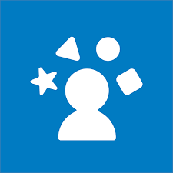**Uploading Documentation to Teaching Strategies Teacher App**